Pentagal Chemie und Maschinenbau GmbH installed an automatic HAL-machine with exchangeable solder-pot at Schweizer Electronic AG
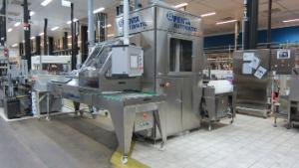
Due to the numerous existing directives for leaded solder at the HAL finish, most PCB manufacturers are forced to operate a second HAL system in addition to the lead-free system, using Pb/Sn- solder.
Schweizer Electronic AG has set itself the goal to realize a new, modern and economic system which can process both surfaces.
After intensive discussions with the project management and all stakeholders of Schweizer Electronic AG, Pentagal accepted this new challenge and developed a Penta Automatic with two solder-pots, which could be exchanged. The aims for the technical implementation were both set close concerning time and security for the solder-pot exchange.
The development and construction of the new automated system was carried out in close collaboration with Schweizer Electronic AG. Pentagal benefited from the extensive experience of the employees of Schweizer Electronic AG.
The system was installed at the turn of 2012/13 and put into operation in early January.
The automatically operating Hot Air Leveling machine detects the solder pot in use, and adjusts the software to the appropriate solder. The experiences made at Schweizer Electronic AG show that the secured solder-pot exchange, which is performed with a mobile lifting device, takes just 15 minutes. The operator is guided through the procedure by a menu in the process visualization. All parameters and stored production menus are loaded, so that a consistent and reproducible quality can be achieved. Simultaneously, the second solder pot is mounted in a stand-by station, and if necessary held on temperature.

